## Part 1: factory plus command; Part 2: all three together, a) iterator, b) observer, c)factory

pattern matching is text description

## Part1

* *Part 1:* Select a design pattern (among the ones studied in the class) that is most appropriate for the problem above and describe how it is applied. You are expected to give the name, participant mapping, and class diagram that illustrate your application of the pattern to this problem.

Command, Factory for different OS.

Participant mapping:

Factory:There is one OS interface for three different operating systems.

Command: Each OS has an InstallerInterface as the abstract base class in the Command design pattern. Format, Defragment and SetUp are Command classes.

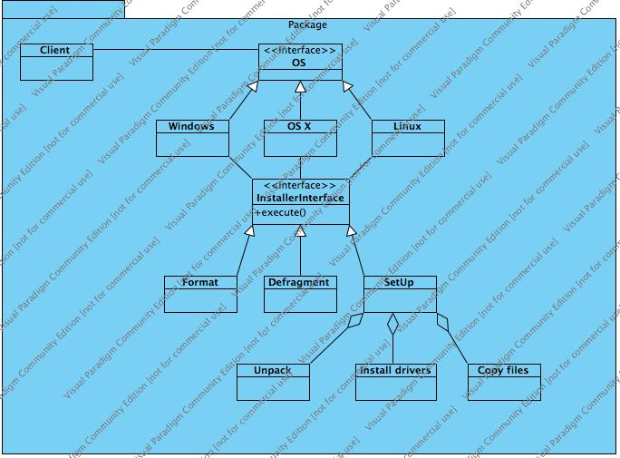

## 

## Part2

1. Iterator

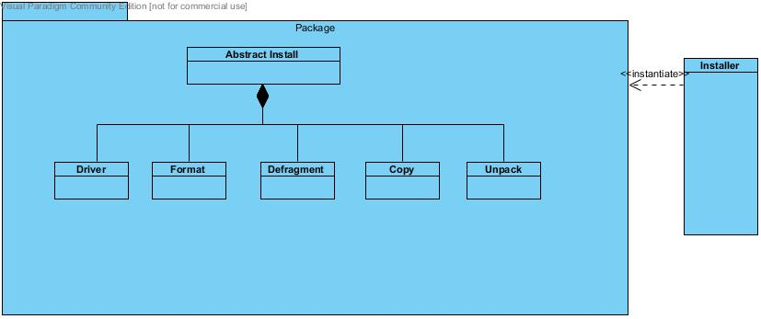

2.

The installer displays a progress bar which reflects how close the program is to completing all the tasks. Also, the cursor will animate during the progress of the installation.

Observer, the progress bar needs to observe the progress to update itself.

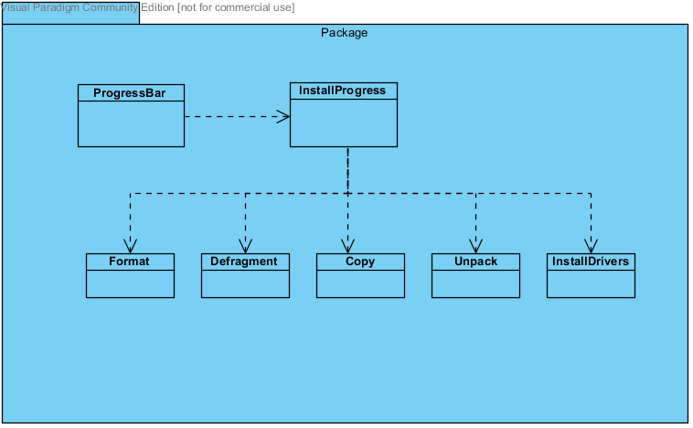

3. The design of the installer should support both remote and local install procedures. For instance, if Internet connection is not available, the system automatically switches to local installation mode.

State.

States allows the object to alter its behaviour when the internal state changes. In this case the internal state is the internet connection and when connection is lost the system switches to local mode.

Class Diagram:

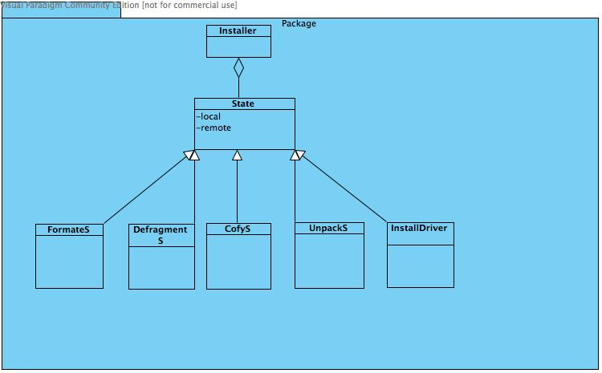

Participate Mapping

